GitLab configuration in Ubuntu and Guidelines
Document ID: ASP-QA-GL-01

Author: Vinoth Suthananthan

Copyright notice: Copyright © 1996-2014 Aspire Systems. All rights reserved. The contents on this document are not to be reproduced or duplicated in any form or kind, either in part or full, without written consent from Aspire Systems.

Table of Contents

1. Update the Packages 3
2. Ruby Installation 4
3. Create a new System User 4
4. Gitlab Shell 4
5. Setup Database 5
6. Gitlab 6
6.1 Clone the Source 6
6.2 Configure Gitlab 6
6.3 Configure Gitlab DB settings 7
6.4 Install Gems 7
6.5 Initialize Database and Activate Advanced Features 7
6.6 Install init script 8
7. Installing Nginx 8
8. Troubleshooting 9
9. Gitlab Guidelines 10
9.1 Creating Groups and repository 11
9.2 Adding SSH keys into Gitlab 13
9.3 Cloning the repository 15
9.4 Creating User Access 18

Update the Packages
- Run the following commands as root user to update the system packages.
apt-get update -y
apt-get upgrade –y
apt-get install sudo –y
- Install the other required packages
sudo apt-get install -y build-essential zlib1g-dev libyaml-dev libssl-dev libgdbm-dev libreadline-dev libncurses5-dev libffi-dev curl openssh-server redis-server checkinstall libxml2-dev libxslt-dev libcurl4-openssl-dev libicu-dev logrotate
- Python should be installed in the server to configure Gitlab.
# Install Python
sudo apt-get install -y python

# Make sure that Python is 2.5+ (3.x is not supported at the moment) If it's Python 3 you might need to install Python 2 separately
python --version
sudo apt-get install -y python2.7

# Make sure you can access Python via python2
python2 --version

# If you get a "command not found" error create a link to the python binary
sudo ln -s /usr/bin/python /usr/bin/python2

# For reStructuredText markup language support install required package:
sudo apt-get install -y python-docutils
- Install Git which should be version 1.7.10 or higher.
sudo apt-get install -y git-core
git --version
- If the Git installed is old, remove the older version and install the latest.
# Remove packaged Git
sudo apt-get remove git-core

# Install dependencies
sudo apt-get install -y libcurl4-openssl-dev libexpat1-dev gettext libz-dev libssl-dev build-essential

# Download and compile from source
cd /tmp
curl --progress https://git-core.googlecode.com/files/git-1.8.4.1.tar.gz | tar xz
cd git-1.8.4.1/
make prefix=/usr/local all

# Install into /usr/local/bin
sudo make prefix=/usr/local install

# When editing config/gitlab.yml, change the git bin_path to /usr/local/bin/git
- In order to receive mail notifications, make sure to install a mail server
sudo apt-get install -y postfix
- Then select 'Internet Site' and press enter to confirm the hostname

Ruby Installation
- Remove the older version of Ruby if installed.
sudo apt-get remove ruby1.8
- Download the latest ruby version and install it.
mkdir /tmp/ruby && cd /tmp/ruby
curl --progress ftp://ftp.ruby-lang.org/pub/ruby/2.0/ruby-2.0.0-p247.tar.gz | tar xz
cd ruby-2.0.0-p247
./configure --disable-install-rdoc
make
sudo make install
- Then install the bundler gem, which is used to install gems from gemfile.
sudo gem install bundler --no-ri --no-rdoc

Create a new System User
We create a new user to use Gitlab as ‘git’
sudo adduser --disabled-login --gecos 'GitLab' git

Gitlab Shell
GitLab Shell is an ssh access and repository management software developed specially for GitLab.
# Go to home directory
cd /home/git
# Clone gitlab shell
sudo -u git -H git clone https://github.com/gitlabhq/gitlab-shell.git
cd gitlab-shell
# switch to right version
sudo -u git -H git checkout v1.7.6
sudo -u git -H cp config.yml.example config.yml
# Edit config and replace gitlab_url with something like 'http://domain.com/'
sudo -u git -H editor config.yml
# Do setup
sudo -u git -H ./bin/install

Setup Database
- Gitlab supports the databases MySQL and PostgreSQL. Recommended is MySQL so, proceeding with MySQL installation.
# Install the database packages
sudo apt-get install -y mysql-server mysql-client libmysqlclient-dev

# Pick a database root password (can be anything), type it and press enter
# Retype the database root password and press enter
# Secure your installation.
sudo mysql_secure_installation

# Login to MySQL
mysql -u root -p

# Type the database root password

# Create a user for GitLab do not type the 'mysql>', this is part of the prompt
# change $password in the command below to a real password you pick
mysql> CREATE USER 'gitlab@localhost' IDENTIFIED BY '$password';

# Create the GitLab production database
mysql> CREATE DATABASE IF NOT EXISTS `gitlabhq_production` DEFAULT CHARACTER SET `utf8` COLLATE `utf8_unicode_ci`;

# Grant the GitLab user necessary permissions on the table.
mysql> GRANT SELECT, LOCK TABLES, INSERT, UPDATE, DELETE, CREATE, DROP, INDEX, ALTER ON `gitlabhq_production`.* TO 'gitlab@localhost';

# Quit the database session
mysql> \q

# Try connecting to the new database with the new user
sudo -u git -H mysql -u gitlab -p -D gitlabhq_production

# Type the password you replaced $password with earlier
# You should now see a 'mysql>' prompt
# Quit the database session
mysql> \q

Gitlab
- We will install Gitlab in the home directory of the user ‘git’, so move to the git user.
cd /home/git

Clone the Source
# Clone GitLab repository
sudo -u git -H git clone https://github.com/gitlabhq/gitlabhq.git gitlab

# Go to gitlab dir
cd /home/git/gitlab

# Checkout to stable release
sudo -u git -H git checkout 6-2-stable
  - 6-2-stable is the stable version available and change it to the latest stable version based on the release.

Configure Gitlab
cd /home/git/gitlab
# Copy the example GitLab config
sudo -u git -H cp config/gitlab.yml.example config/gitlab.yml

# Make sure to change "localhost" to the fully-qualified domain name or
# IP of your host serving GitLab where necessary
# If you installed Git from source, change the git bin_path to /usr/local/bin/git
sudo -u git -H editor config/gitlab.yml

# Make sure GitLab can write to the log/ and tmp/ directories
sudo chown -R git log/
sudo chown -R git tmp/
sudo chmod -R u+rwX log/
sudo chmod -R u+rwX tmp/

# create directory for satellites
sudo -u git -H mkdir /home/git/gitlab-satellites

# create directories for sockets/pids and make sure GitLab can write to them
sudo -u git -H mkdir tmp/pids/
sudo -u git -H mkdir tmp/sockets/
sudo chmod -R u+rwX tmp/pids/
sudo chmod -R u+rwX tmp/sockets/

# create public/uploads directory otherwise backup will fail
sudo -u git -H mkdir public/uploads
sudo chmod -R u+rwX public/uploads

# Copy the example Unicorn config
sudo -u git -H cp config/unicorn.rb.example config/unicorn.rb

# Enable cluster mode if you expect to have a high load instance
# Ex. change amount of workers to 3 for 2GB RAM server
sudo -u git -H editor config/unicorn.rb

# Copy the example Rack attack config
sudo -u git -H cp config/initializers/rack_attack.rb.example config/initializers/rack_attack.rb

# Enable rack attack middleware
# Find and uncomment the line 'config.middleware.use Rack::Attack'
sudo -u git -H editor config/application.rb

# Configure Git global settings for git user, useful when editing via web
# Edit user.email according to what is set in gitlab.yml
sudo -u git -H git config --global user.name "GitLab"
sudo -u git -H git config --global user.email "gitlab@localhost"
sudo -u git -H git config --global core.autocrlf input

Configure Gitlab DB settings
# Mysql
sudo -u git cp config/database.yml.mysql config/database.yml

# Make sure to update username/password in config/database.yml.
# You only need to adapt the production settings (first part).
# If you followed the database guide then please do as follows:
# Change 'secure password' with the value you have given to $password
# You can keep the double quotes around the password
sudo -u git -H editor config/database.yml

# Make config/database.yml readable to git only
sudo -u git -H chmod o-rwx config/database.yml

Install Gems
cd /home/git/gitlab

sudo gem install charlock_holmes --version '0.6.9.4'

# For MySQL (note, the option says "without ... postgres")
sudo -u git -H bundle install --deployment --without development test postgres aws

Initialize Database and Activate Advanced Features
sudo -u git -H bundle exec rake gitlab:setup RAILS_ENV=production

# Type 'yes' to create the database.

# When done you see 'Administrator account created:'

Install init script
  - Download the init script (will be /etc/init.d/gitlab):
sudo cp lib/support/init.d/gitlab /etc/init.d/gitlab
sudo chmod +x /etc/init.d/gitlab
  - Make GitLab start on boot:
sudo update-rc.d gitlab defaults 21

  - And setup logrotate by,
sudo cp lib/support/logrotate/gitlab /etc/logrotate.d/gitlab
  - And check the gitlab is configured correctly by,
sudo -u git -H bundle exec rake gitlab:env:info RAILS_ENV=production
  - Start the Gitlab instance
sudo service gitlab start
# or
sudo /etc/init.d/gitlab restart
  - And check the status of the configuration.
sudo -u git -H bundle exec rake gitlab:check RAILS_ENV=production

Installing Nginx
  - Nginx is the officially supported web server for Gitlab. If you want to use other servers please refer here.
sudo apt-get install -y nginx
  - Download an example site config:
sudo cp lib/support/nginx/gitlab /etc/nginx/sites-available/gitlab
sudo ln -s /etc/nginx/sites-available/gitlab /etc/nginx/sites-enabled/gitlab
  - Make sure to edit the config file to match your setup:
# Change YOUR_SERVER_FQDN to the fully-qualified
# domain name of that we gave earlier in the section 6.2.
sudo editor /etc/nginx/sites-available/gitlab
  - Now restart the nginx server to apply the changes.
sudo service nginx restart

Troubleshooting
Visit the domain name given in the section 6.2 in the browser and it should be redirected to the Gitlab login page as below
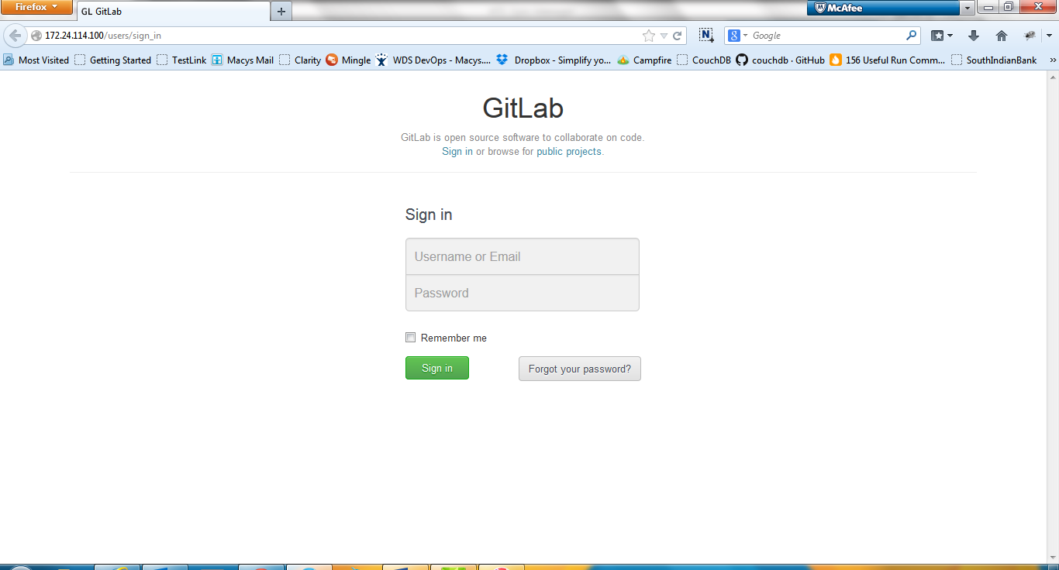
- If any error like 502 bad gateway or page cannot be displayed, then Gitlab is not properly configured.
- Mostly the issue comes when restarting the service Nginx, because the apache2 service and the nginx service access the same port(80) to start the service.
- Change the port for the nginx service in the file called ‘default’ which will be in the location ‘/etc/nginx/sites-available’
~:# cd /etc/nginx/sites-available
:/etc/nginx/sites-available# editor default
- The file default will be opened for editing. In that change the port number to ‘listen 83’ instead of ‘listen 80’ and uncomment that line.
- So, finally the line will be looking like, ‘listen 83; ## listen for ipv4; this line is default and implied’ and before it was like ‘#listen 80; ## listen for ipv4; this line is default and implied’
- To save the file press Esc + : + wq. The file will be modified and saved.
- Now try to restart the service nginx, ‘sudo service nginx restart’.
- Otherwise, give some other port number for apache2 server to start.

Gitlab Guidelines
The initial user name is admin@local.host and the password is ‘5iveL!fe’. The password is generated automatically by Gitlab and after successful login you will be asked to change password.
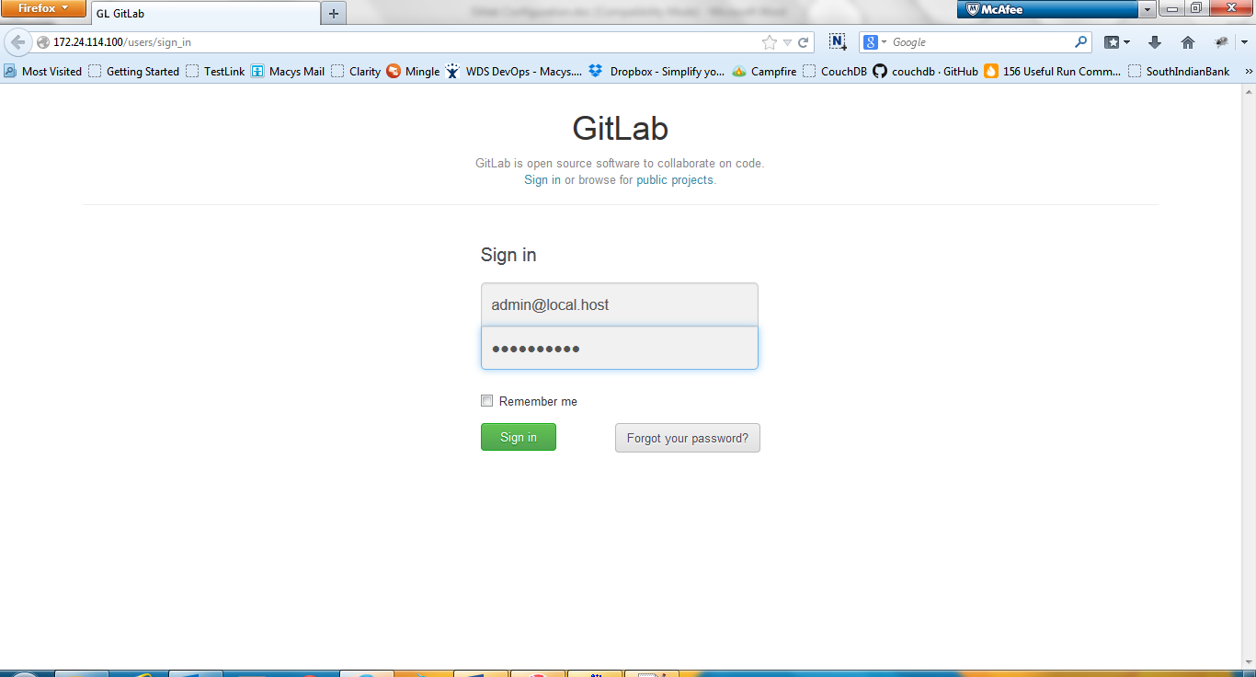
After the password change, you will be redirected to the following page.
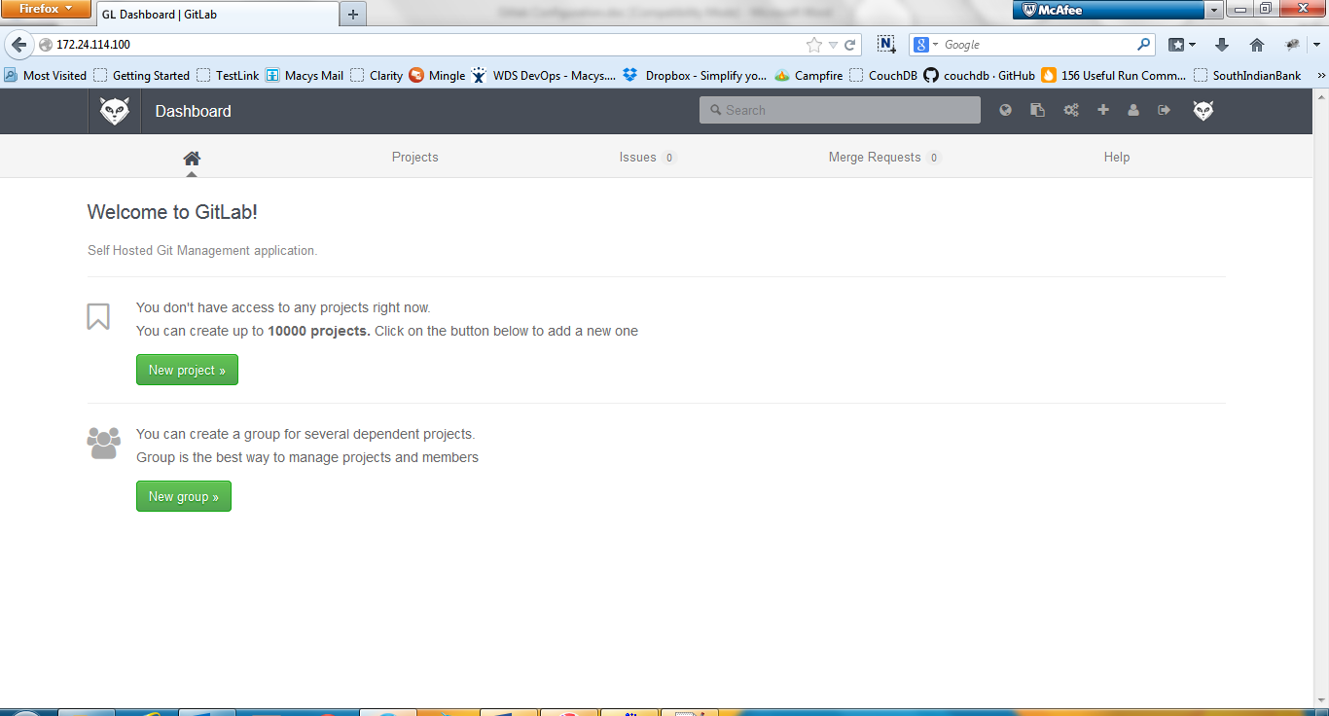

Creating Groups and repository
  - Create a new group, so that new projects can be created under a specified group.
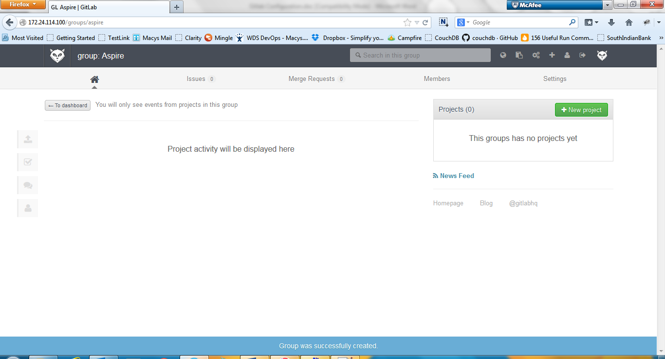

  - Now create a new project from the created group.
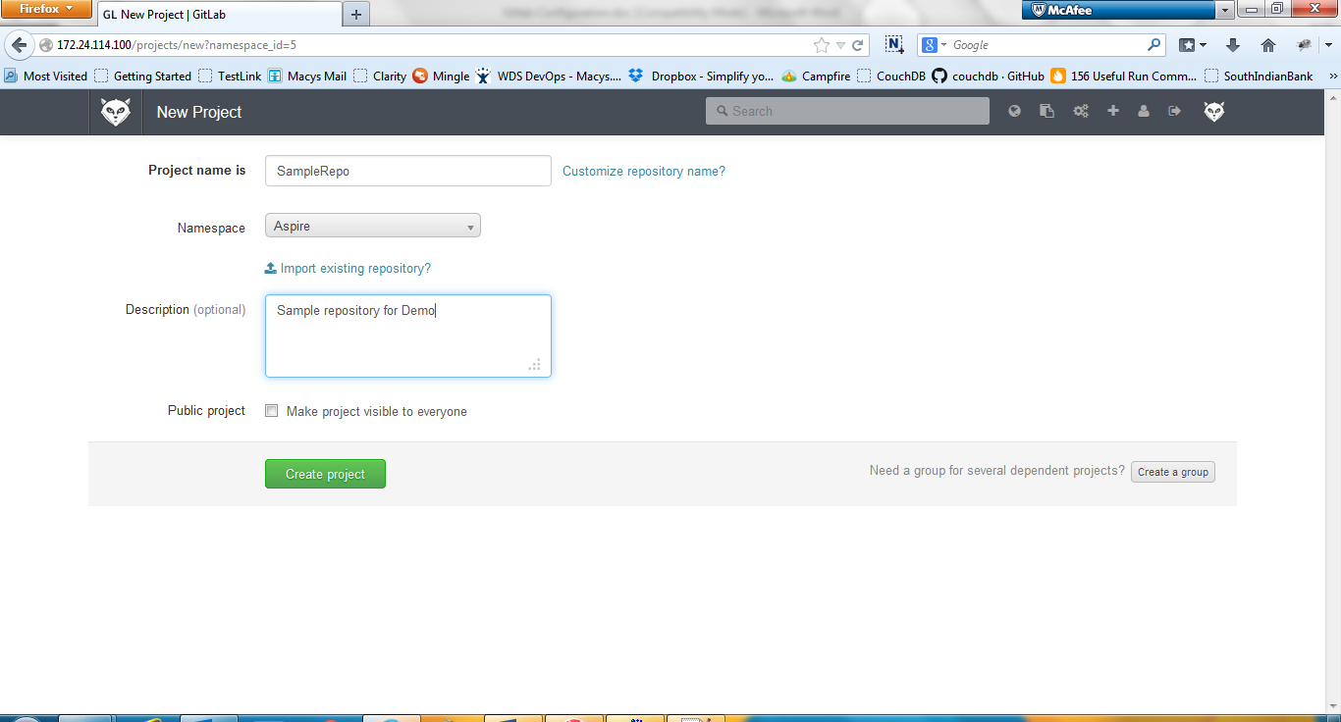
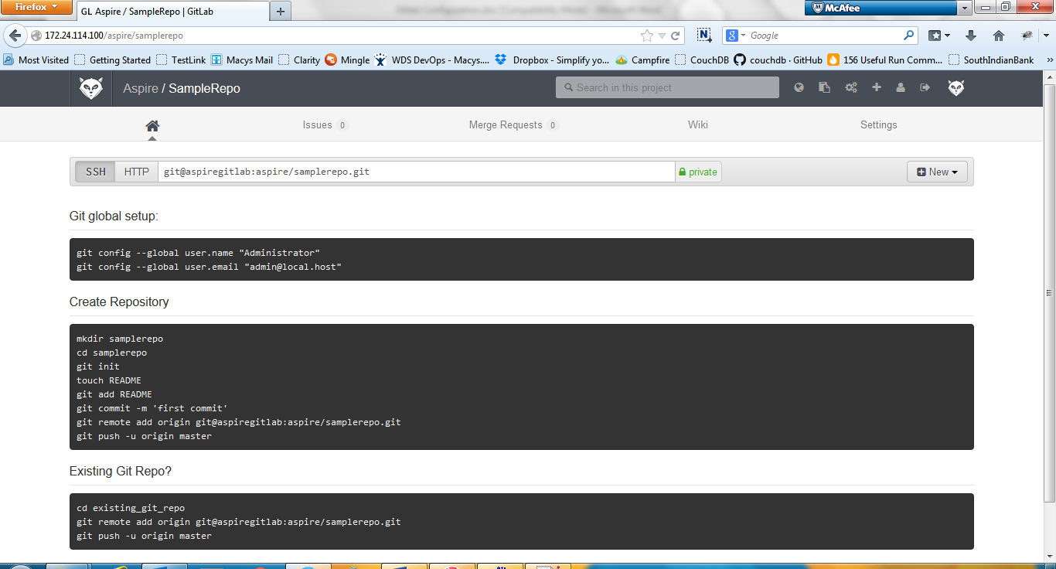
  - Now an empty repository is created in the server.

Adding SSH keys into Gitlab
  - Authentication for the projects can be provided with the help of SSh keys.
  - For that, SSH keys should be generated in the machine in which repo needs to be accessed. (For now call it as UserSystem)
  - Install Gitbash in the UserSystem from here.
  - Then open GitBash and give the following command.
ssh-keygen -t rsa
- Hit enter to set the location to save the key, by default it will be under ‘users/user.name/.ssh’ in windows and in Linux based systems it will be under ‘/root/.ssh/id_rsa’.
- Give a password if necessary else just hit enter for no password.
- Now the generated SSH key should be added into the Gitlab to give access to the UserSystem.
- To add SSH keys into Gitlab, goto Profile Settings at the top right menubar and select SSH Keys from the available top level menus.
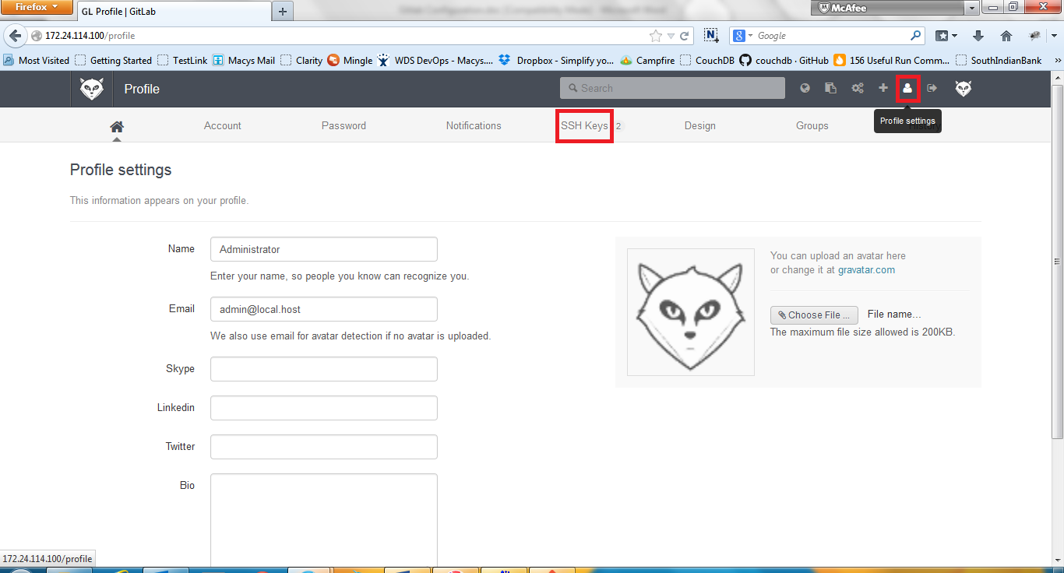
- Click ‘Add SSH key’ button at the top and give the name of the user and paste their SSH key then add it.
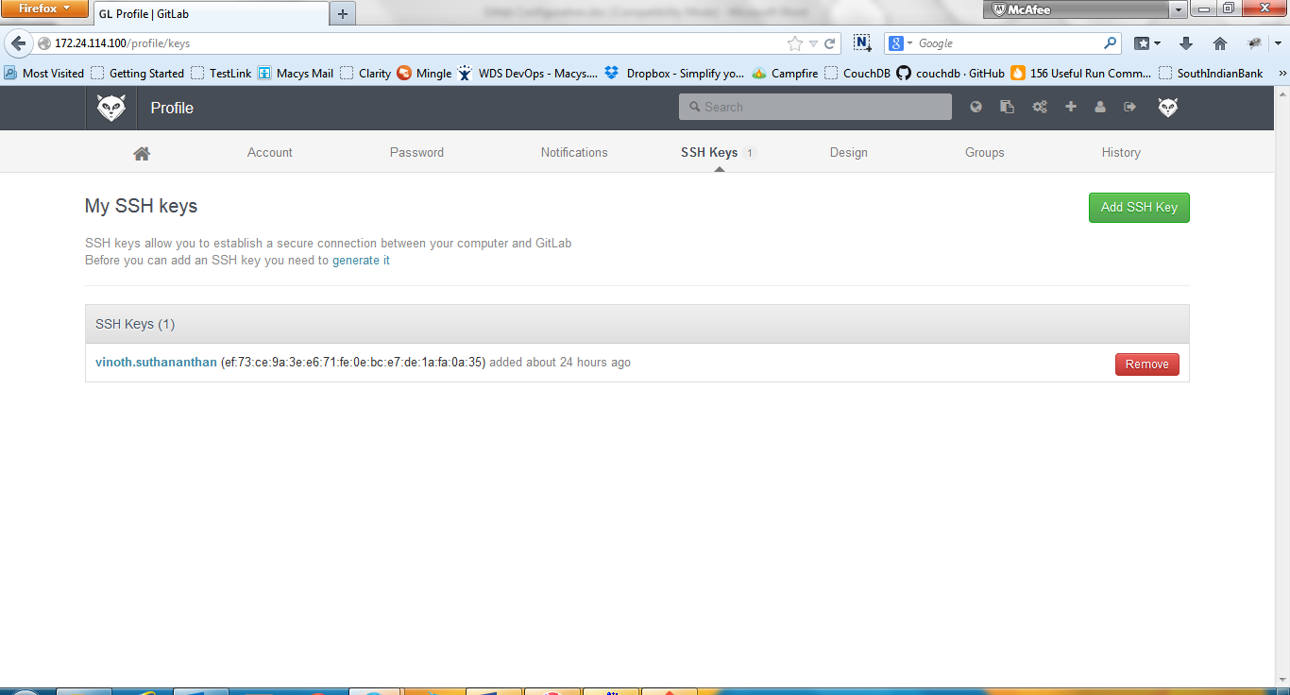
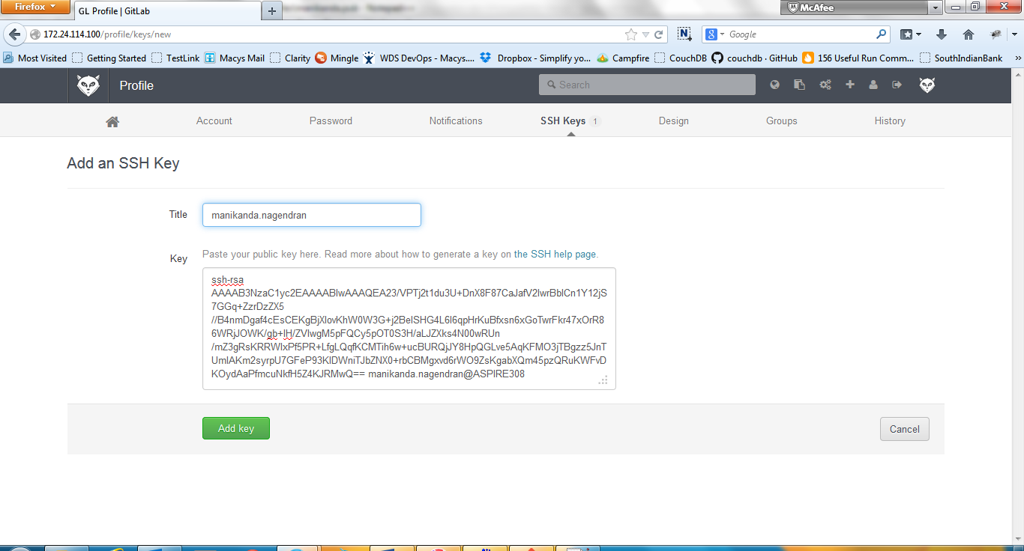
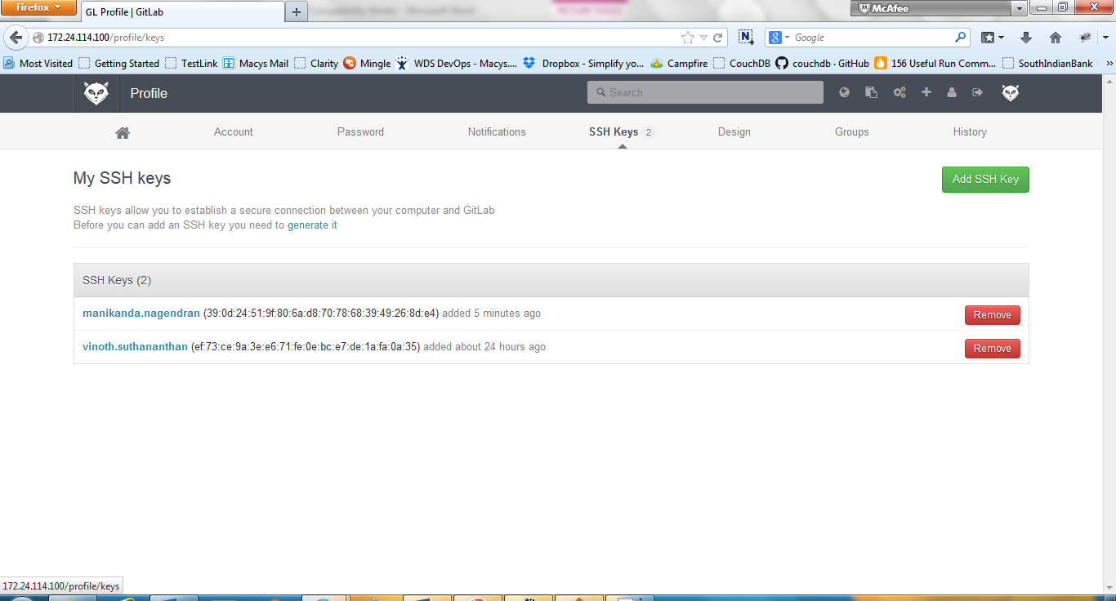

Cloning the repository
- Now UserSystem is authenticated to clone the repository, since SSH key is added.
- Open GitBash in the UserSystem and clone the repository with the following command,
git clone git@172.24.114.100:aspire/samplerepo.git
- The ‘git clone’ clones a repository into a newly created directory and the ‘git@172.24.114.100:aspire/samplerepo.git’ points to the repo we created.
- The ‘git’ is the system username that we created in section 3. And 172.24.114.100 refers to the domain that was given instead of localhost. aspire refers to the group we created in the Gitlab and samplerepo.git points to the repository.
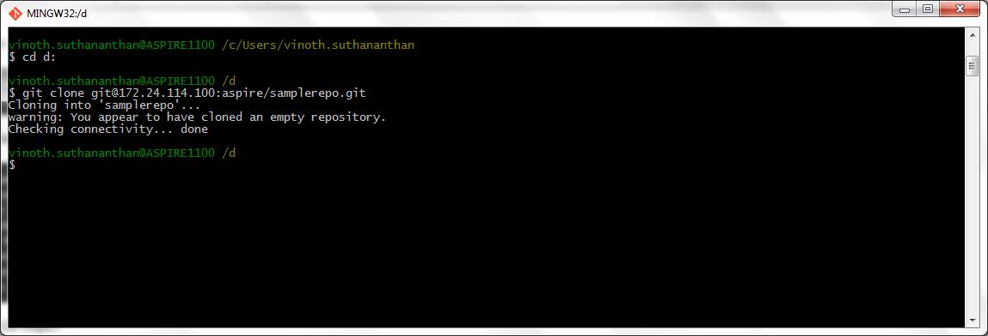
- Since the repo don’t have any files, warning message will be displayed as, ‘warning: You appear to have cloned an empty repository.’ So an initial commit should be done in the repo.
- Navigate to the project folder, include the files required.
- Since the files are added newly, that should be added into git using ‘git add <file_name>’.
- If more than one file needs to be added, use ‘git add -A’ to stage every files.
- Commit the changes with the commit message and push into the master.
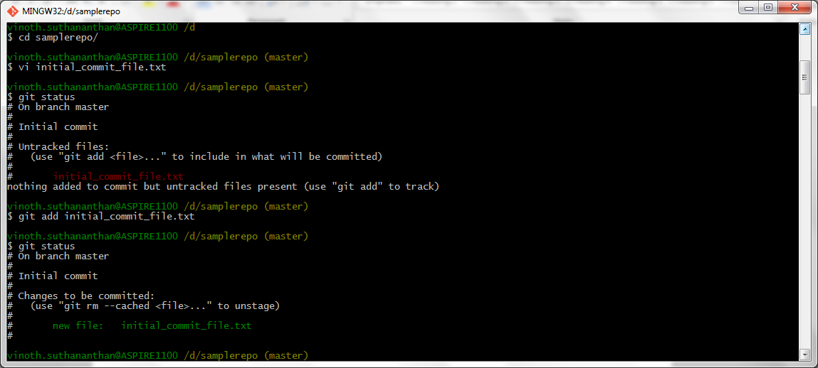
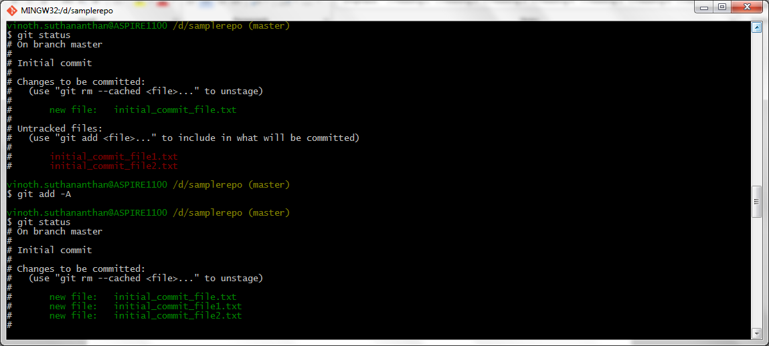
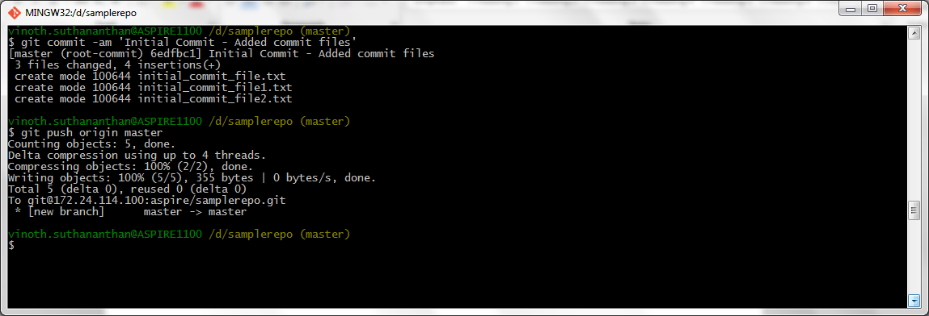
- In the Gitlab, goto Home, there the changes did will be displayed.
- Click ‘Files’ in the second level menu to see the committed files.
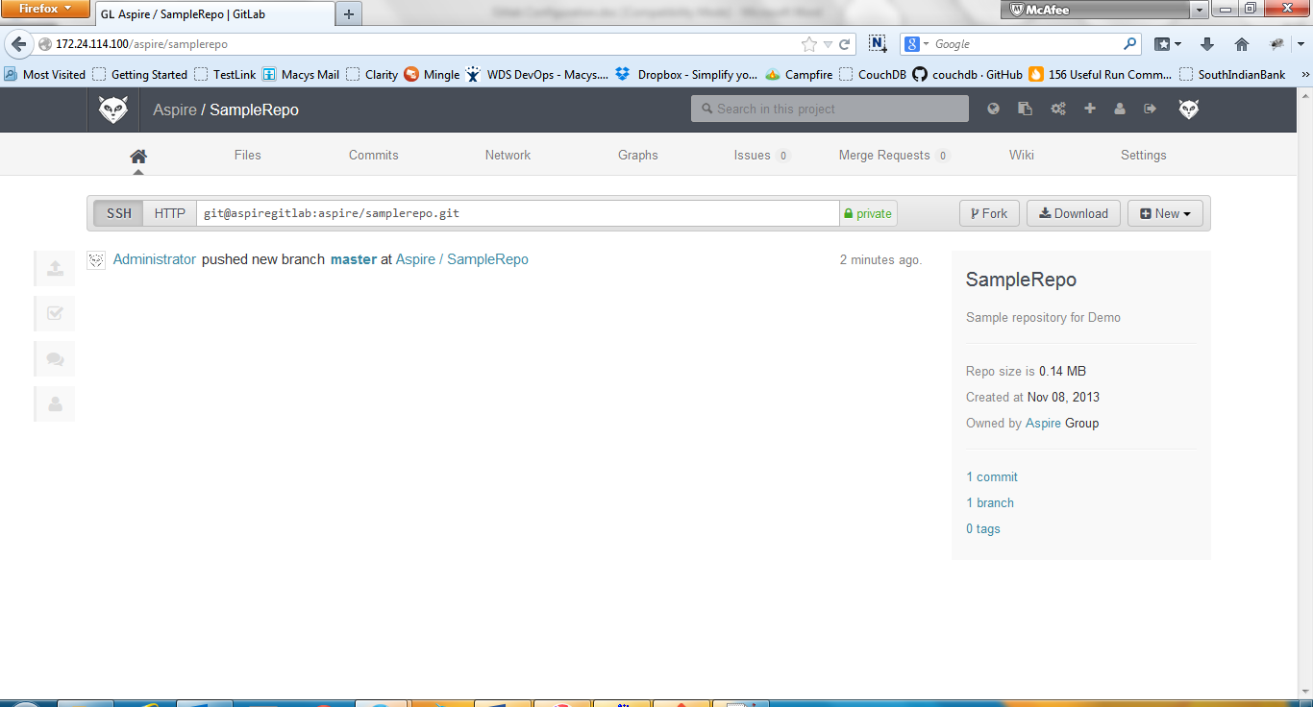
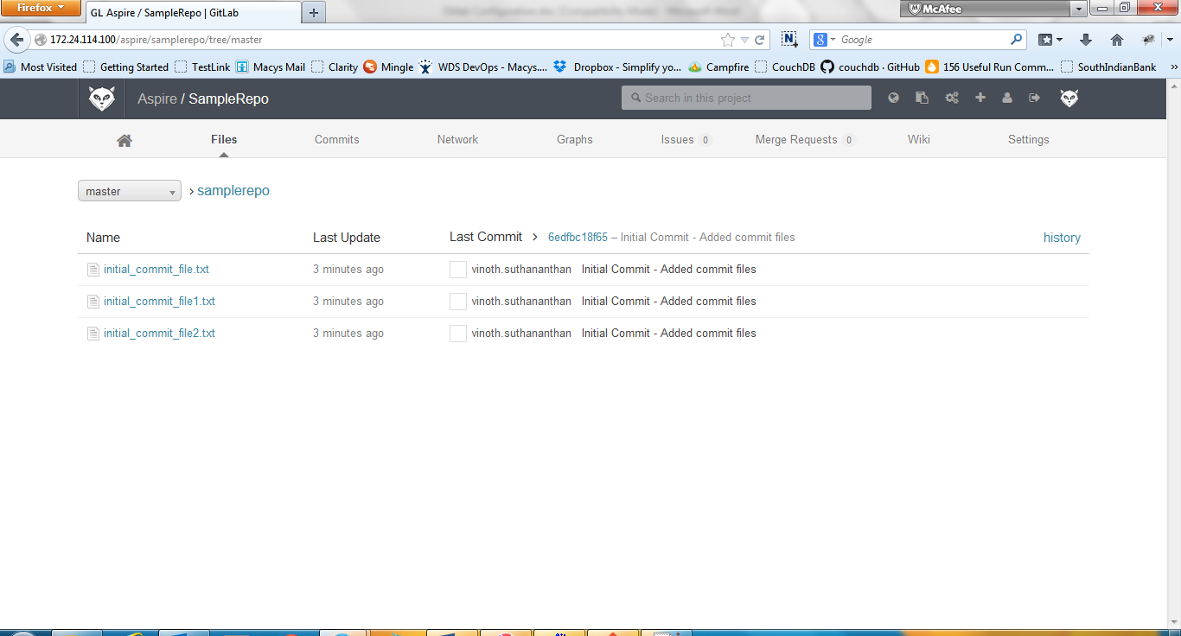

Creating User Access
- A repository can have more number of users, permissions for the users will be different based on their role.
- GitLab gives access to provide right authentication to the users.
- Go to ‘Admin area’ and select ‘New user’ from the users section.
- Provide the user details and a valid email of the user, to which the temporary password will be sent.
- The user can use the GitLab URL to login and prompted to change password.
- Then user have to add his/her SSH key in the SSH key section to get access to the repository.
- To provide access to the users, go to the repository -> Settings and select Members from the left side menus.
- Select ‘New project member’ button from top right side.
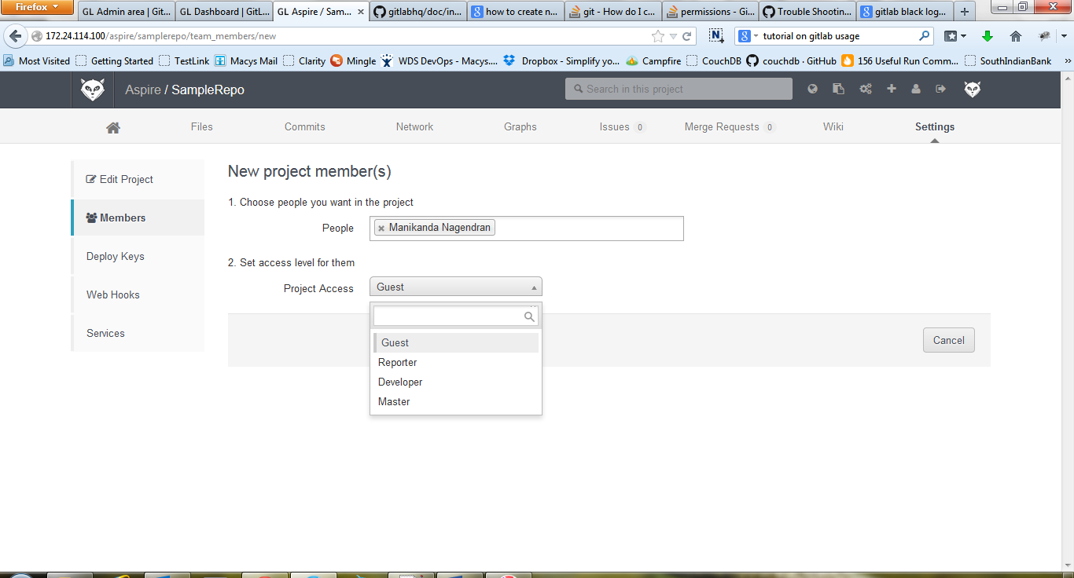
- In the people field, the added users will be displayed. Select the user and access level from the available access rights (Guest, Reporter, Developer and Master) and add the user.
- Now the user is added into the repo with the access level set.
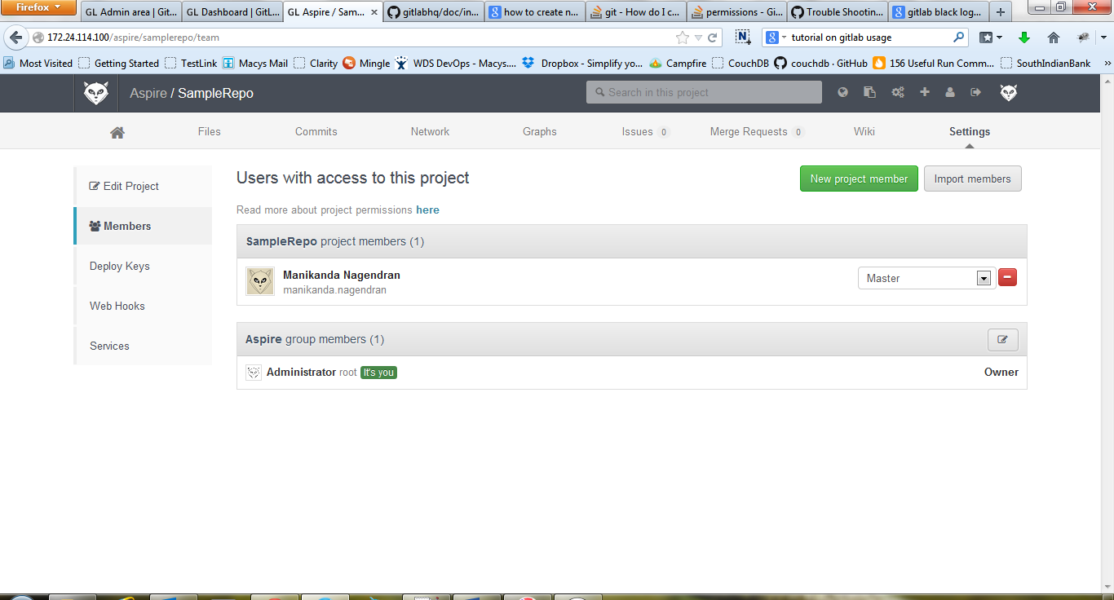
- If the user did not receive any email for the temporary password, then there is an issue in ‘postfix’ service installed in the server.
- Postfix service is used by Gitlab to send email, so need to reconfigure it if any issues.
- Give the command ‘sudo dpkg-reconfigure postfix’ to reconfigure.
- While reconfiguring, select ‘Internet Site’ option from the different options displayed.
- And continue with the default options in the configuration.
- Type ‘telnet localhost 25’ and type following one by one to check the configuration,
mail from: gitlab@localhost.com
rcpt to: someone@example.com (give valid email id)
data
Subject: sample
Data to be sent as email
.
Quit
- After this, the recipient email will receive the email if the configuration is correct.
- The access levels are having the authentication limits as follows,
